**EXHIBIT A-1**

**Premises**

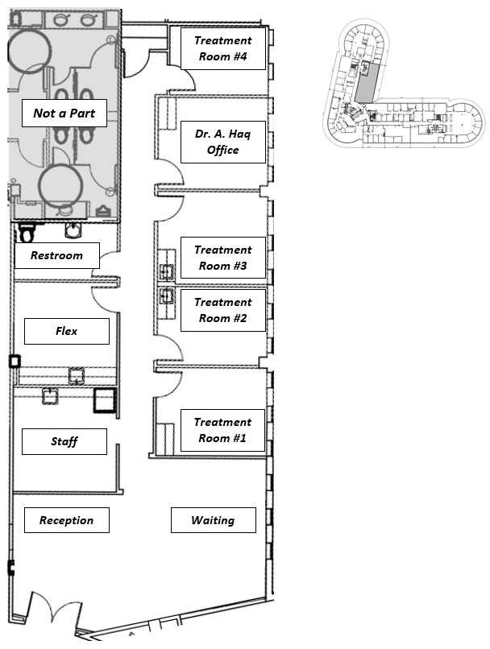

**EXHIBIT A-1**

**Detailed Scope of Work**

General

* Remove existing decal from suite entry door and frosting for privacy.
* Add framing/support to reception area wall to support logo/signage.
* Remove floor anchors and repair floor in reception area.
* Paint ceiling grid, paint or replace diffusers, and replace all ceiling tiles. Tiles in all treatment rooms to be higher noise reduction model such as Armstrong Mesa or Ultima, as selected by Tenant.
* Patch and paint all walls in premises, color to be selected by Tenant.
* Replace wall plates as needed for consistency throughout premises.

Treatment Room #1

* Relocate any ‘middle of wall’ power and data outlets to lower code compliant positions.
* Verify working 240V outlet or provide if non-existent.
* Install new door/door frame to office entry.
* Install relocated upper cabinet from Dr. A. Haq office to Treatment Room #1.
* Install matched lower cabinet/counter unit in pre-existing location.

Treatment Room #2

* Relocate any ‘middle of wall’ power and data outlets to lower code compliant positions.
* Verify working 240V outlet or provide if non-existent.
* Install new door/door frame to office entry.
* Existing millwork and plumbing to remain.

Treatment Room #3

* Relocate any ‘middle of wall’ power and data outlets to lower code compliant positions.
* Verify working 240V outlet or provide if non-existent.
* Install new door/door frame to office entry.
* Demo/patch bulkhead where millwork has been removed.
* Cap-off / patch walls where existing plumbing exists.
* Patch flooring where millwork has been removed.

Dr. A. Haq Office

* Relocate any ‘middle of wall’ power and data outlets to lower code compliant positions.
* Install new door/door frame to office entry.
* Demo/patch bulkhead where millwork has been removed.
* Patch flooring where millwork has been removed.

Treatment Room #4

* Relocate any ‘middle of wall’ power and data outlets to lower code compliant positions.
* Verify working 240V outlet or provide if non-existent.
* Install new door/door frame to office entry.

Restroom

* Repair/patch wall in Washer/Dryer recess area.
* Install Toilet Paper Holder.
* Replace painted black cove base with white to match remainder of premises.

Flex

* Replace painted black cove base with white to match remainder of premises.

Staff

* Replace painted black cove base with white to match remainder of premises.
* Install standard refrigerator in space provided, color/finish to be selected by Tenant.